**Final Project – (200 Points Total):**

This is an extremely detail oriented assignment! Please spend the time necessary to complete this assignment as thoroughly as you possibly can since it will be most beneficial to you in the long run!

**Part I – (150 Points):**

There are a number of topics on here. You may need to research certain topics and others you may have within your class notes from the labs and lectures. For each topic, you should provide a detailed description and/or explanation of what the topic is (in your own words). Following the description/explanation you will create an example topology that will be used for this question. (Yes, you may utilize this same topology on other questions – only if it directly relates to other questions.) Make sure you specify interfaces in use, ip addresses and subnet masks within your topology. Next, you will provide a configuration for the topic listed based upon your example topology. For the first few questions, you should provide detailed steps as to where you are within the router or switch when issuing a specific command so you demonstrate basic knowledge and manipulation of the Cisco IOS. Throughout all of the topics you should specify what each command does. (A brief example is listed below.) After you have finished the topic configuration you should provide any show commands that would verify the configuration for that specific topic. Following the show commands, specify how you would test the topic configuration (possibly via specific debug commands, etc…).

*Please keep in mind… No assumptions are made! Some of the items have multiple steps so be sure to include* ***all*** *the steps in the configuration to receive full credit for that particular topic.*

**For example:**

If you are asked to ***assign an IP Address to a router interface***, you may want to specify the following:

Create a sample topology, then write…

An IP Address is a Layer 3 logical address that is assigned to each host within a TCP/IP network. The IP Address assigned to the host is determined by the network administrator and is dependent upon the network it is directly connected to. An IP Address is a hierarchical address that consists of 4 octets, 8 bits each, 32 bits in total. An IP Address is typically written in dotted decimal notation:

* + - 1. is an example of a Class A IP Address

To assign an IP Address to a router interface you would proceed in the following manner:

|  |  |
| --- | --- |
| Router> | This prompt specifies the router is in USER mode |
| Router>***enable*** | this command is entered to go from USER mode to PRIVILEGE mode |
| Router# | You are now in PRIVILEGE mode |
| Router# ***configure terminal*** | used to enter GLOBAL CONFIGURATION mode from PRIVILEGE mode. This is needed to configure all parameters within the router |
| Router(config)# | You are now in GLOBAL CONFIGURATION mode |
| Router(config)#***interface fastethernet0/0*** | This is entered to go into INTERFACE CONFIGURATION mode to configure the fastethernet0/0 interface within the router |
| Router(config-if)# | You are now in INTERFACE CONFIGURATION mode |
| Router(config-if)#***ip address 1.1.1.1 255.0.0.0*** | This sets the IP Address to 1.1.1.1 with a subnet mask of 255.0.0.0 which is the default subnet mask for a Class A IP Address |
| Router(config-if)#***no shutdown*** | After the IP Address is set on the interface, it’s always a good idea to enable the interface and test connectivity. |

Then… Specify the show commands, test commands to verify the configuration is working properly and move onto the next topic. You should use telnet, ping, and traceroute for testing and troubleshooting. So, for each question you should have the following:



When answering each question, please keep your responses in this order.

Topics to research, explain, provide detail and provide examples for: (make sure you provide as much detail as possible in a concise manner and make it as legible as possible! Once this is graded and turned back to you, it will provide you with a detailed study guide for your final practical.) Please feel free to copy and paste the table from above and use it as a template for each question. Please do not remove the point values, numbers or questions/statements below. Use this as a template and add your answers under each numbered question/statement on each page.

# Research Syntax Exam – (200 Points Total)

*(10 points)*

1. Basic router configuration (NOTE: hostname, ip addresses, passwords for each mode of the router or switch, enabling interfaces, etc…)

A: Basic router configuration is the bare minimum an individual must complete in order to get his or her router onto a network. You set a password for privileged mode, define a host name, set appropriate IP addresses for interfaces, configure console lines and vty lines 0 – 4, and disable ip domain lookup.

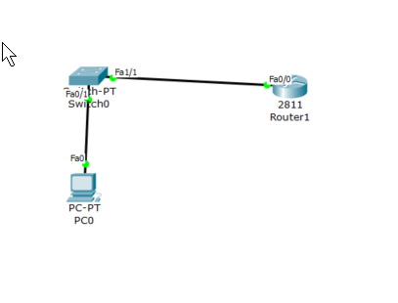

|  |  |
| --- | --- |
| Router> | This prompt specifies the router is in USER mode |
| Router>***enable*** | this command is entered to go from USER mode to PRIVILEGE mode |
| Router# | You are now in PRIVILEGE mode |
| Router# ***configure terminal*** | used to enter GLOBAL CONFIGURATION mode from PRIVILEGE mode. This is needed to configure all parameters within the router |
| Router(config)# | You are now in GLOBAL CONFIGURATION mode |
| Router(config)#***hostname Router1*** | This is entered to essentially name the router. Now the CLI prompt will read “Router1” instead of just “Router” |
| Router1(config)#int fx/x | This will bring you into the interface you wish to configure. |
| Router1(config-if)# | You are now in the interface specified. |
| Router1(config-if)# ip address A.B.C.D W.X.Y.Z | This will assign the ip address and subnet mask you specify to the current interface. |
| Router1(config-if)#no shutdown | This brings the interface you are currently in from a ‘down’ state to an ‘up’. |
| Router1(config-if)#enable password cisco | This creates a password to get into privilege mode of cisco |
| Router1(config)#line con 0 | This allows you to configure your console line port, which is used when you connect your computer via the console port to a Cisco device. |
| Router1(config-line)#password cisco | Sets the password to your console lines to cisco. |
| Router1(config-line)#login | Prompts you for login when accessing console line. |
| Router1(config-line)#logging sy | Enables synchronous logging mode. |
| Router1(config-line)#exit | This is an escape command which brings you back one user mode. So now we will be back into global configuration mode. |
| Router1(config)# | Now in global configuration mode. |
| Router1(config)#line vty 0 4 | This brings you into the configuration mode for your VTY lines. More specifically on lines 0-4 which each correspond to a specific protocol such as SSH or TelNet. |
| Router1(config-line)#password cisco | Creates a password for VTY lines 0-4 of password. |
| Router1(config-line)#login | Prompts a user when entering line vty 0 4 for the password. |
| Router1(config-line)#logging sy | Enables synchronous logging mode for VTY lines. |
| Router1(config-line)#exit |  |
| Router1(config)#no ip domain lookup | Disables the default behavior of the router of attempting to resolve the invalid command a user may enter into an IP address. |

B:

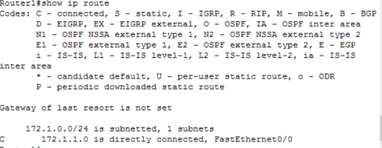

Show ip route

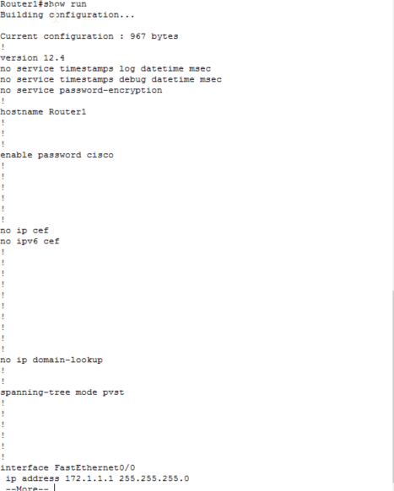

Show run

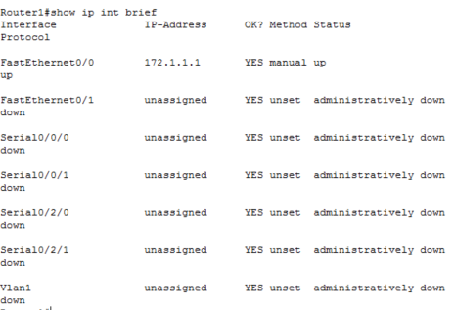

Show ip int brief

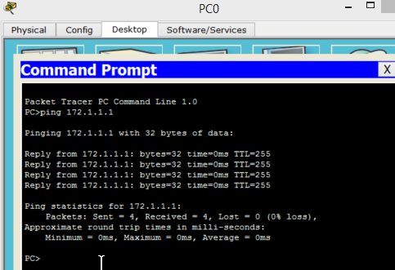

*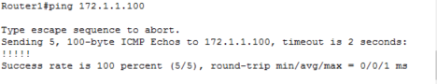(10 points)*

1. STP and the use of portfast (Make sure you specify this for Cisco 2960 and 3560 series switches since this is what we are using this semester in the lab.)

Spanning Tree Protocol is a protocol found on Layer2 of the OSI model that runs on bridges and switches. The main purpose of the protocol is to prevent loops when there are redundant paths in your network. In the topology below, the F0/6 interface of Switch4 is an amber light, this means that all packets from PC0 to PC1 will that the path from Switch4 -> Switch0 and so on. The port is in a block state that will only open if the primary route becomes compromised.

|  |  |
| --- | --- |
| Switch(config)#int range f0/x – X | Allows you to configure multiple interfaces at one time. |
| Switch(config)#int spanning-tree portfast | Enables portfast on all specified ports. |

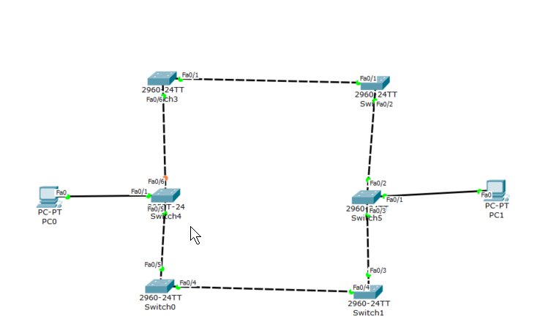

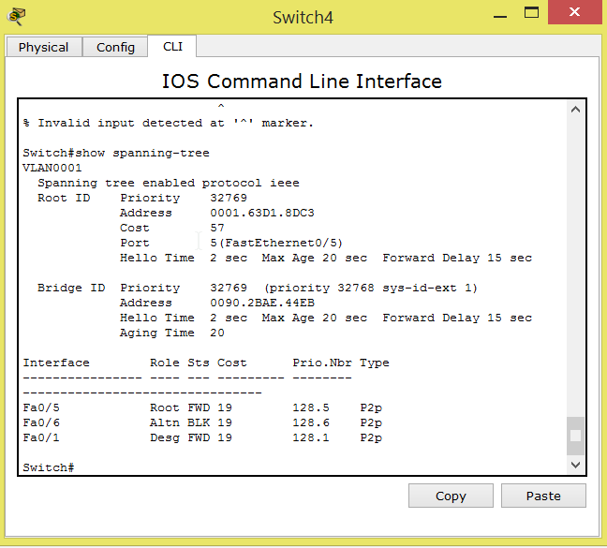

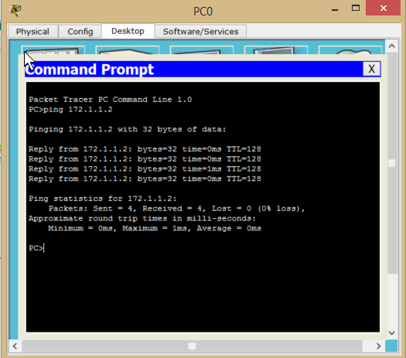

*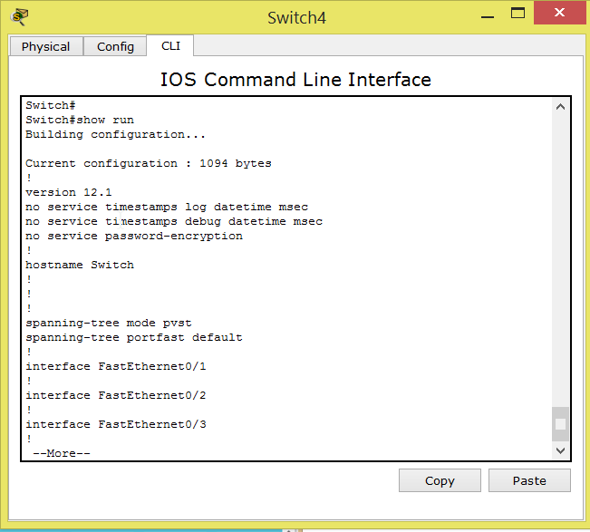(10 points)*

1. VLANs, VTP with 802.1q (NOTE: how to create one or more with names, assigning different interfaces to VLANs, etc… (Make sure you accomplish this without going into VLAN Database mode (this is the deprecated way of configuration for VLANs!) Make sure you setup an IP Address on the administrative VLAN and show the syntax for both 2960 and 3560 switches!)

Vlans create a group of hosts that share a common network regardless of their physical location. Vlans are typically designated through IP subnets. In the topology below I created Vlan 10 and Vlan 20. PC0 and PC5 are on Vlan 10 while PC2 and PC4 are on Vlan 20. PC’s on the same vlan are able to ping each other between switches, while PC’s on separate Vlans are unable to communicate with each other.

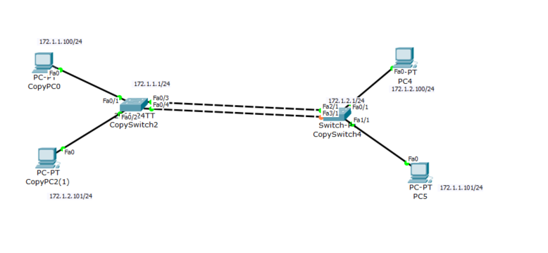

|  |  |
| --- | --- |
| Switch(config)#int vlan 1 <ip address> <subnet mask> | This creates the administrative vlan of a switch. |
| Switch(config)#vlan <vlan number> | Accesses a vlan at a specific number |
| Switch(config)#<name> | Names the vlan |
| Switch(config)#vtp domain <name> | Creates a vtp domain name |
| Switch(config)#vtp password <password> | Sets vtp domain password |
| Switch(config)#vtp mode <client/server> | Assigns the VTP to be either a client or a server |
| Switch(config)#int fx/x | Accesses an inferface |
| Switch(config-if)#switchport mode access | Ensures that the specified interface will only belong to VLAN |
| Switch(config-if)#switchport access vlan <number> | Assigns a vlan to the interface |
| Switch(config)#int fx/x | Access to a specific interface |
| Switch(config-if)#switchport mode trunk | Makes the connection between switches serve as a trunk. |
| Switch(config-if)#switchport trunk encapsulation dot1q | *Specifies the encapsulation mode. This is only used for 3560 |

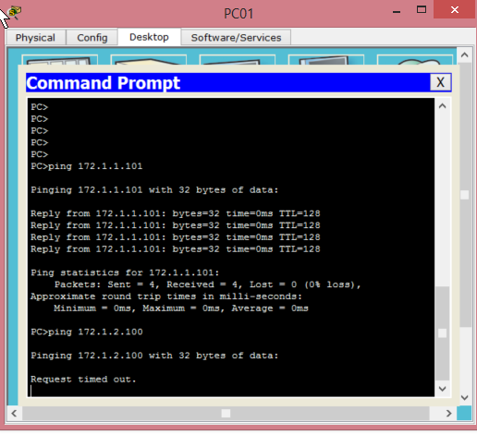

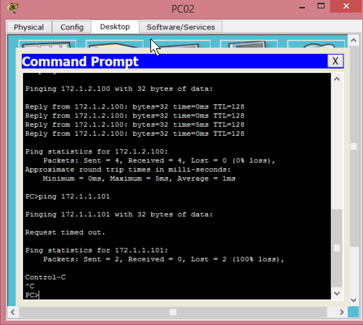

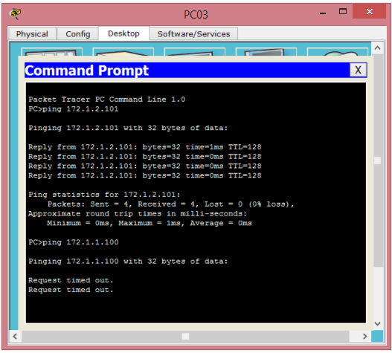

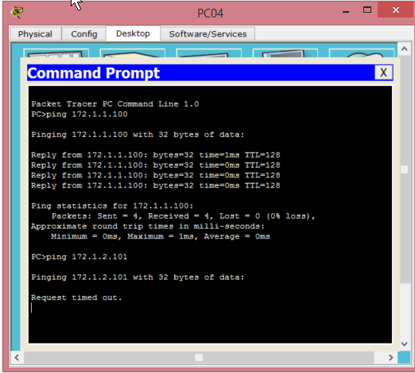

Show vlan

Show int trunk

Show vtp status

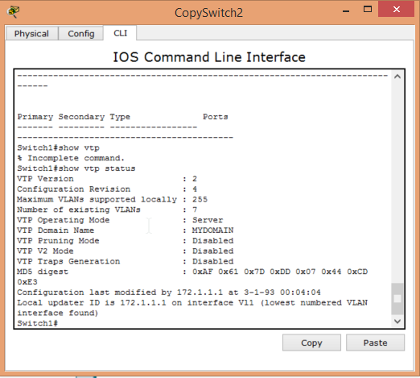

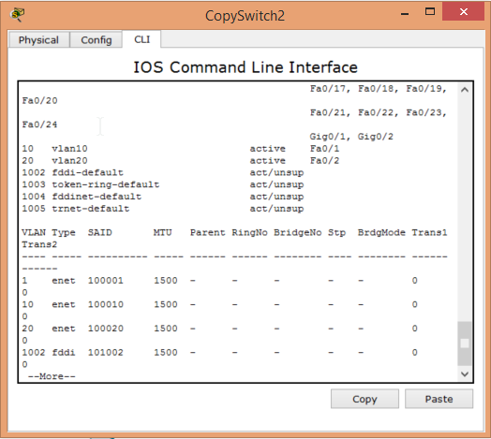

*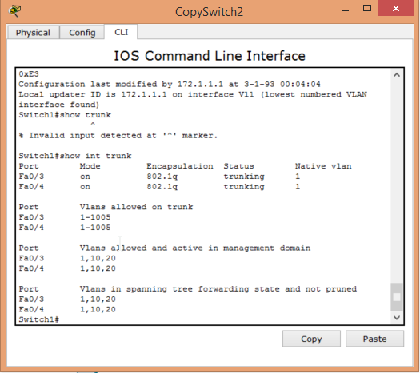(10 points)*

1. Inter-VLAN routing (NOTE: With a router-on-a-stick and SVIs)

A ‘router on a stick’ serves as a logical connection between two logically attached hosts that are on separate routing domains. For example, in the previous topology PC01 and PC02 couldn’t communicate with each other even though they were physically on the same switch because they were assigned to different VLANS. The router on the stick allows for

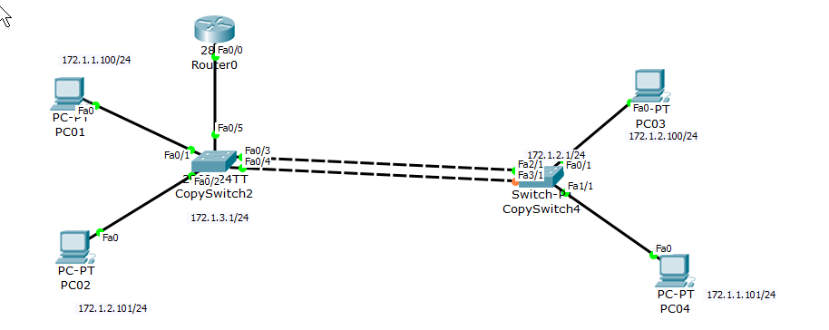

|  |  |
| --- | --- |
| Router1(config)#int <interface directly connected to the switch> | Brings you into the interface that is directly connected to the switch. |
| Router1(config)#no ip address | Assign the interface no ip address |
| Router1(config)#shutdown | Shuts down the interface |
| Router1(config)#int f0/0.1 | Allows you to configure the sub-interface that is connected to the administrative vlan of the switch |
| Router1(config-)#encapsulation dot1q 1 | Enables IEEE 802.1Q**encapsulation** of traffic on a specified subinterface in VLANs |
| Router1(config)#ip address <nearest vlan network + 1> <subnet mask> | Assigns the ip address of the administrative vlan to the sub interface f0/0.1 |
| Router1(config)#int f0/0.10 | Allows you to configure the sub-interface that will be associated with vlan 10 |
| Router1(config-subif)#encapsulation dot1q 10 | Enables IEEE 802.1Q**encapsulation** of traffic on a specified subinterface in VLANs |
| Router1(config-subif)#ip address <nearest vlan network + 1> <subnet mask> | Assigns the ip address of vlan 10 to the sub-interface f0/0.10 |
| Router1(config)#int f0/0.20 | Allows you to configure the sub interface that is associated with vlan 20 |
| Router1(config-subif)# encapsulation dot1q 10 | Enables IEEE 802.1Q**encapsulation** of traffic on a specified subinterface in VLANs |
| Router1(config-subif)# ip address <nearest vlan network + 1> <subnet mask> | Assigns the ip address of vlan 10 to the sub-interface f0/0.10 |
| Router1(config)#int f0/0 | Brings you back to the interface connected to the switch |
| Router1(config-if)#no shutdown | Brings the interface back up. |

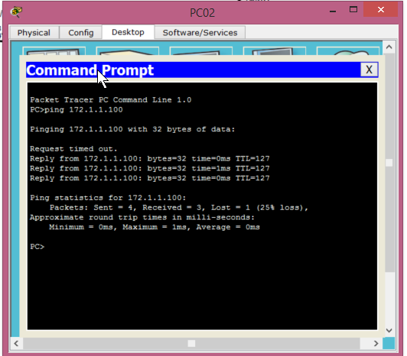

*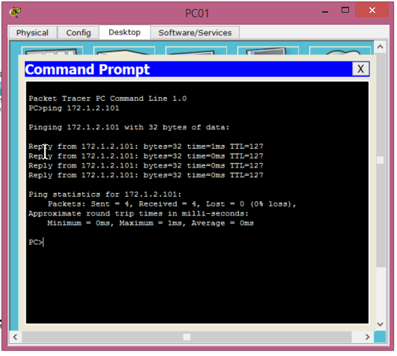(10 points)*

1. Static routing (NOTE: With AND Without the use of a default static route.)

A: In this example we are working to design a network that implements static routing both with and without the use of a default static route. We are defining routes in an explicit manner instead of implementing dynamic protocols such as RIP or OSPF. This means that as an ‘administrator’ if I want two non directly connected networks to be able to talk to each other, I must define a connection between them in order for both routers to have an entry in their routing table.

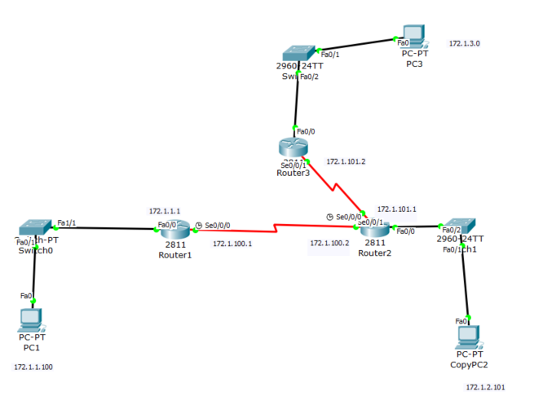

|  |  |
| --- | --- |
| Router(config) int s0/0/x | This brings you into the interface on the WAN connection between two routers |
| Router(config-if)# ip address A.B.C.D W.X.Y.Z | Configures the IP address and subnet mask of the interface you specified. |
| Router(config-if)#no shutdown | Brings the interface from a ‘down’ state to an ‘up’ state. |
| Router1(config-if)#clock rate 2000000 | This sets the clock rate of the DCE interface, in cases where the interface is a DTE interface, no clock rate is set. |
| Router1(config-if)#destination network, subnet mask, next hop address | This creates a static route that gets entered into the routers routing table. |

*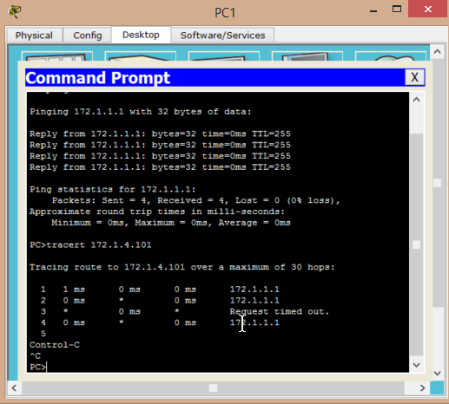No default route*

*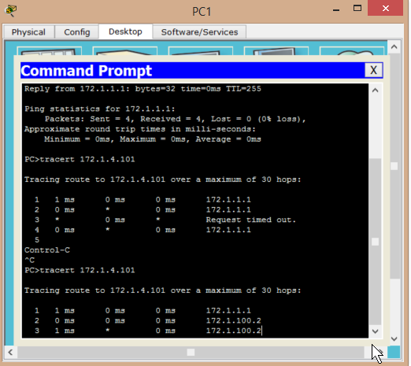Default route*

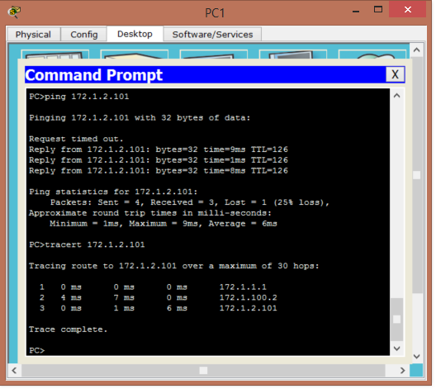

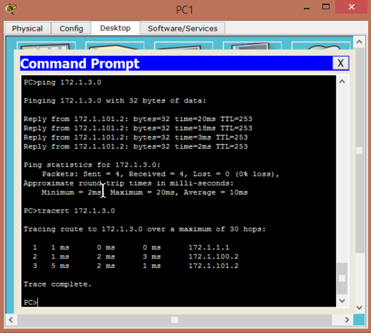

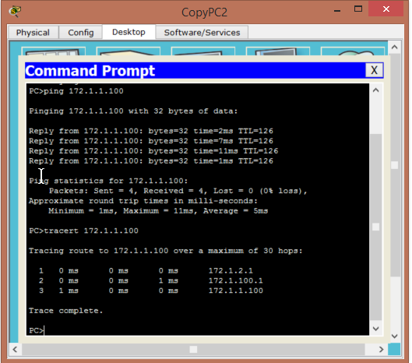

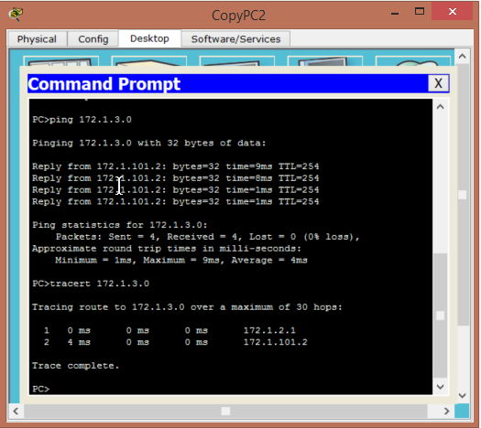

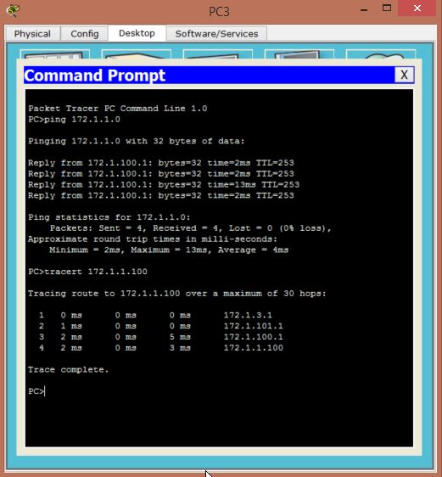

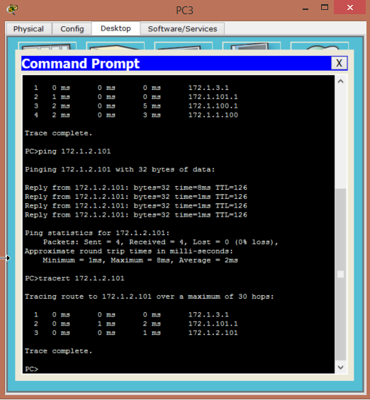

*show ip route*

*show ip int brief*

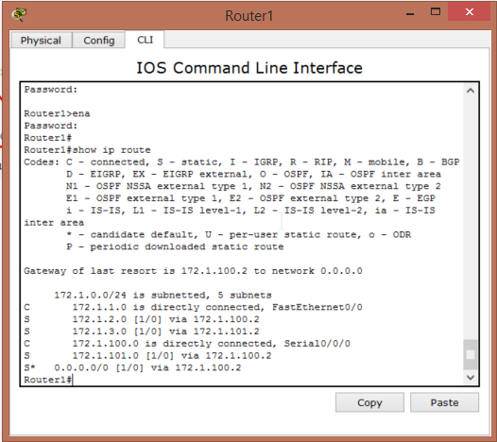

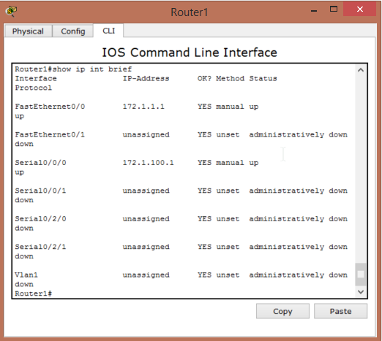

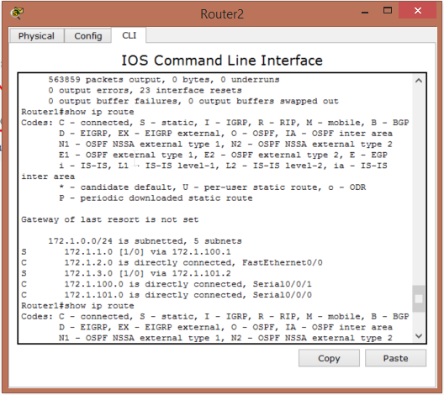

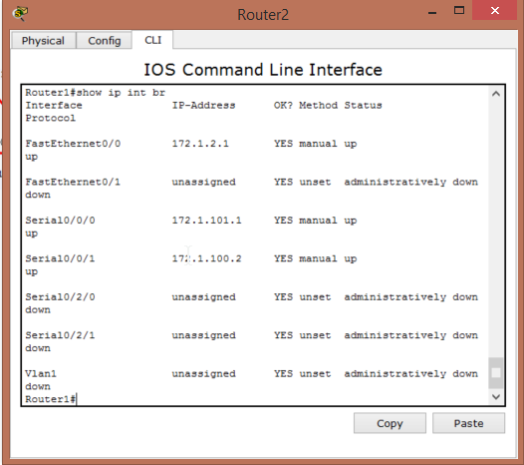

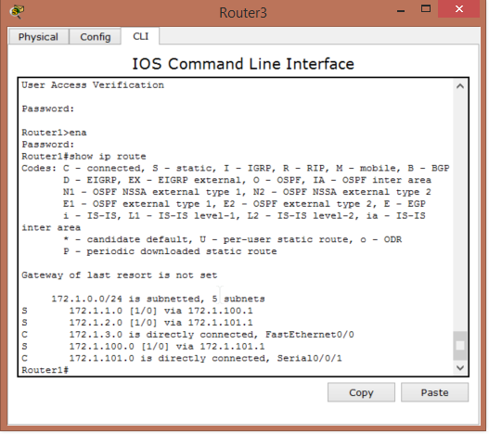

*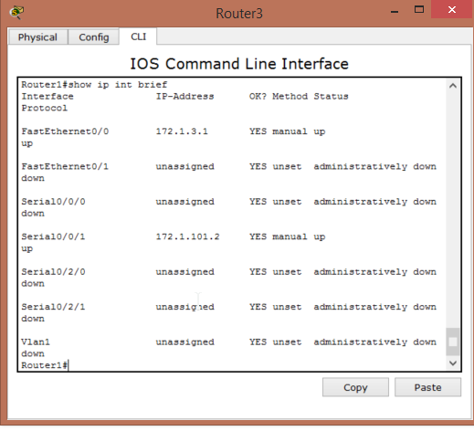(10 points)*

1. RIP and RIPv2

A: In this question we are looking at the dynamic routing protocol of RIP/RIPv2. RIP is a classful protocol meaning that it only takes into account the default subnet mask for the network class IP, while RIPv2 is classless and takes into account the subnet defined by the administrator. RIP protocols sends routing information updates to surrounding networks every 30 seconds which allows two non directly connected routers/hosts to communicate with each other without having an explicit route defined in their respective routing tables.

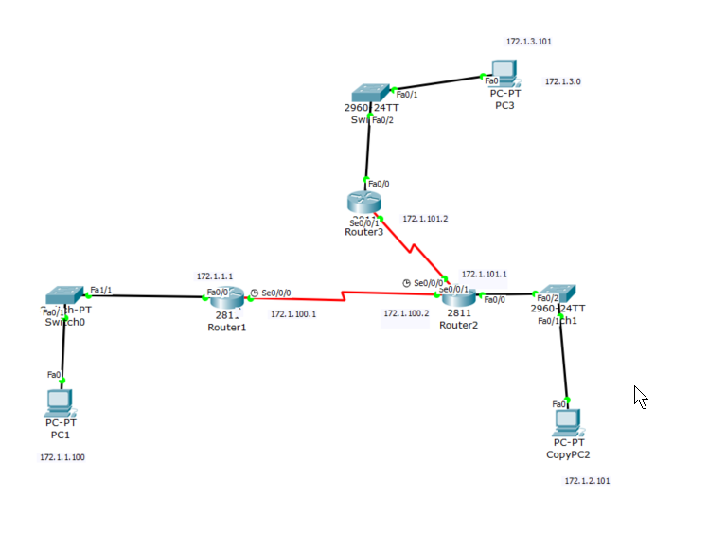

|  |  |
| --- | --- |
| Router(config)#router rip | This sets your router in ‘rip’ mode which allows you to configure rip/ripv2 protocol |
| Router(config)#version 2 | Changes the routing protocol from the default rip to ripv2 |
| Router(config)#network A.B.C.D | Broadcasts the network(s) that an individual router belongs to |
| Router(config)#no ip route destination network subnet mask next hop address | Since a static route has a lower administrative distance than RIP protocol, the static route will take priority. This commands removes the static route. |

**

**

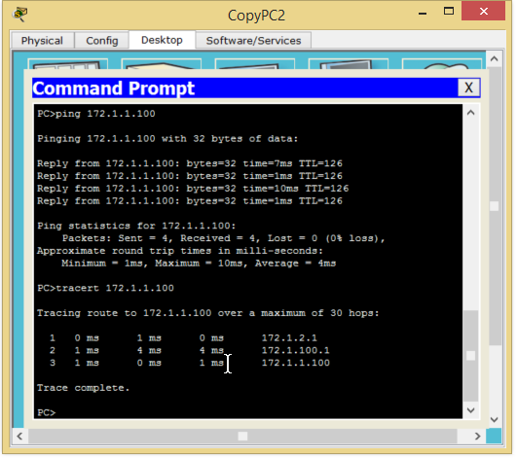

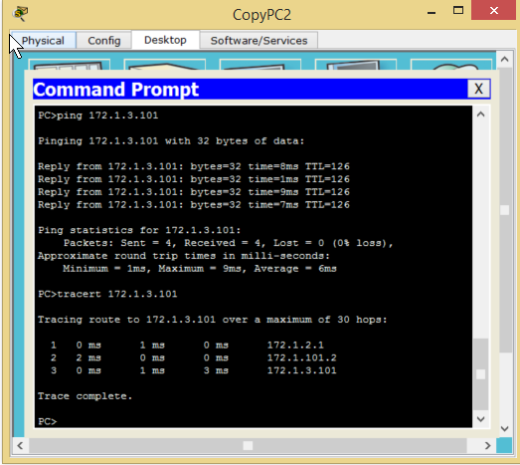

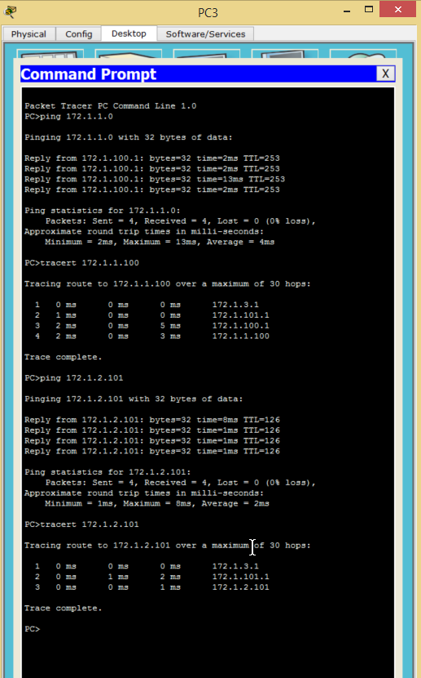

*show ip route*

*show ip int brief*

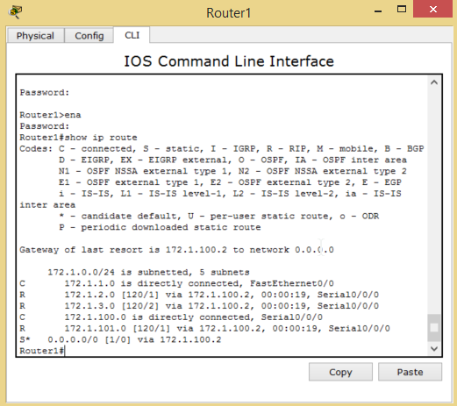

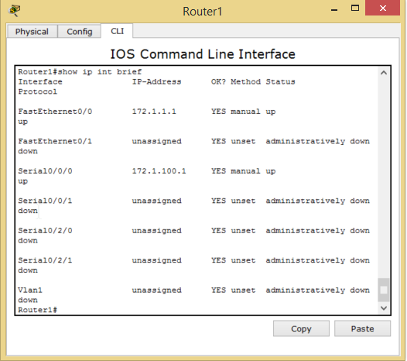

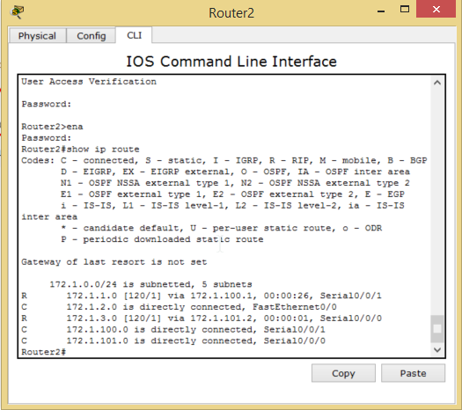

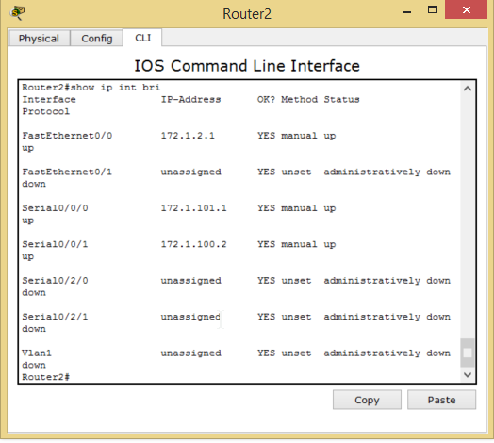

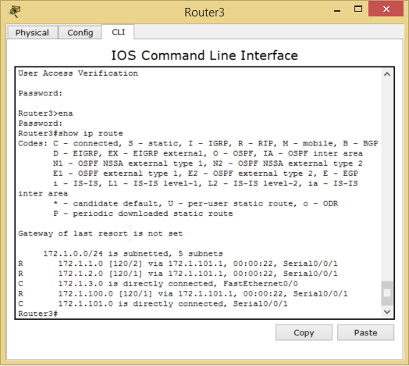

*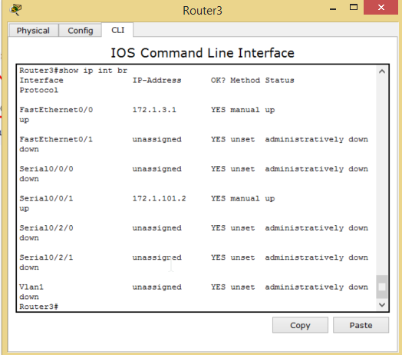(10 points)*

1. EIGRP (NOTE: Make sure you utilize VLSM in your topology and configuration without the use of automatic summarization.)

A: EIGRP is a network protocol that lets routers exchange information more efficiently than with RIP protocols. In this example we configure our routers with EIGRP while also implementing variable length subnet masks. With EIGRP routers build their routing tables by relying on neighboring routers to reliably propagate routing table and routing table changes throughout the network.

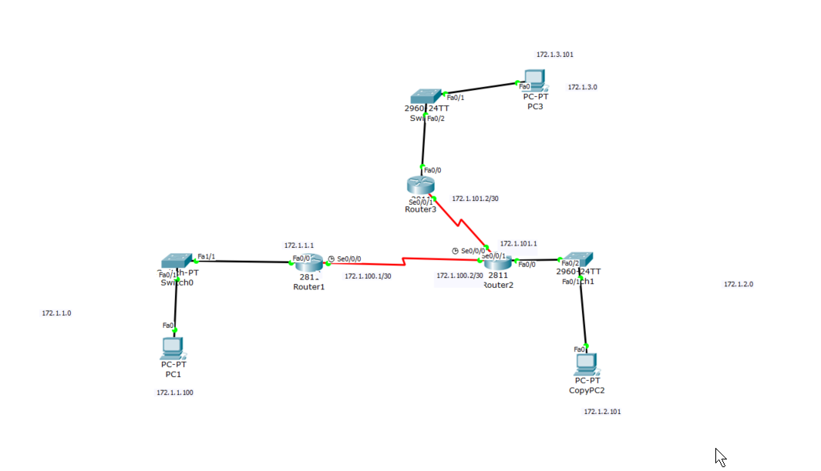

|  |  |
| --- | --- |
| Router(config)#router eigrp 1 | This enabled the EIGRP protocol with an AS number of 1 |
| Router(config-if)#no-auto summary | This command disables auto summary. With auto summary disabled, EIGRP will advertise each specific subnet. |
| Router(config-if)#network A.B.C.D wildcard mask | Allows a router to advertise what network(s) it belongs to. |

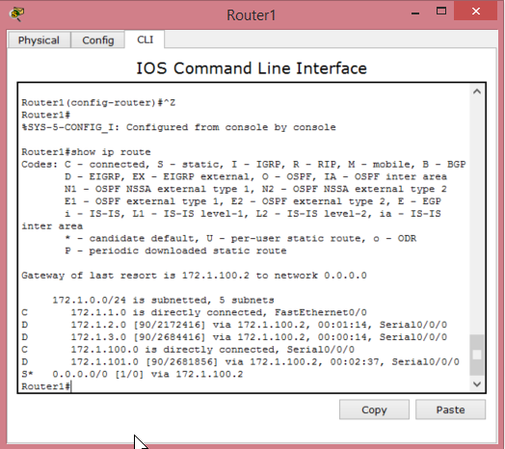

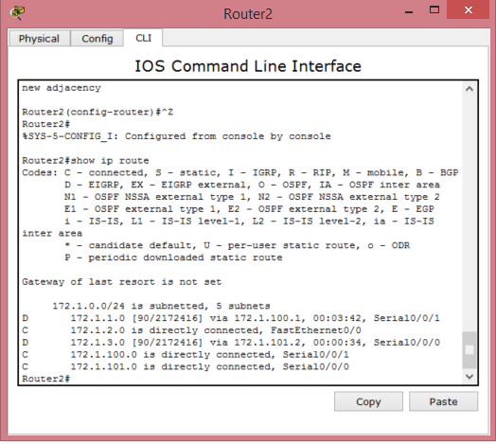

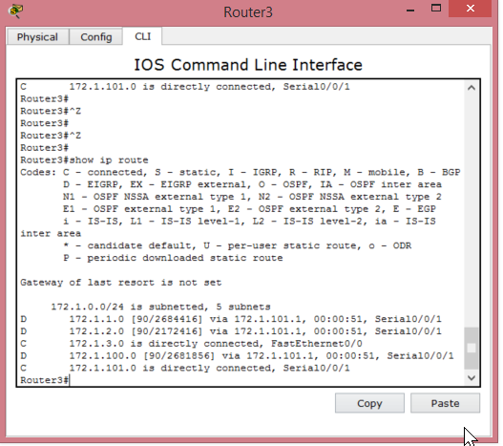

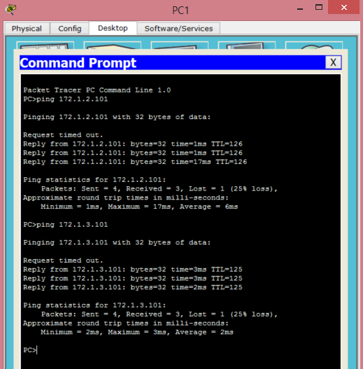

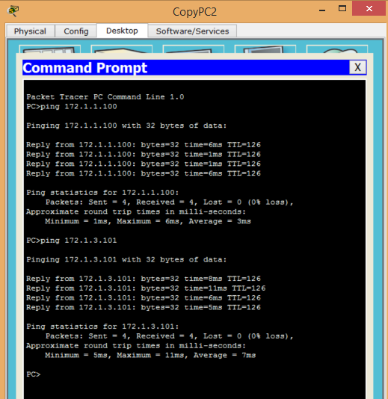

*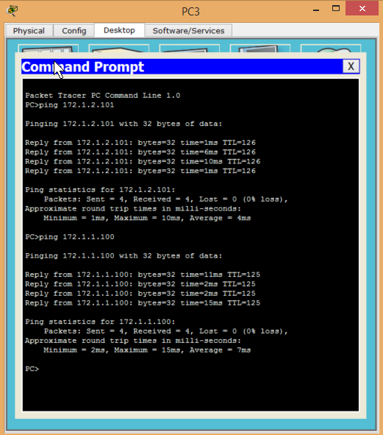(10 points)*

1. OSPF (NOTE: Make sure you utilize loopback interfaces within your topology and configuration…and make sure you specify why you are utilizing them.)

A: This example focuses on using the dynamic routing protocol of OSPF. OSPF stands for Open Shortest path First and uses a link state algorithm in order to connect networks. It is implemented under one AS number and is considered a linked state protocol. OSPF allows a router to learn changes to a routing table from any other router in the network; however, unlike RIP which sends an update every 30 seconds, OSPF only sends updates when a change in the network has taken place.

|  |  |
| --- | --- |
| RouterX(config-if)#router ospf 1 | This enables OSPF on the router with an AS number of 1. |
| RouterX(config-if)#network A.B.C.D W.X.Y.Z area 0 | Sets a network that a router belongs to. Using area 0 means that the router belongs to the “backbone” network. |
| RouterX(config)#interface loopback 0 | Enables a loopback interface on the router. |
| RouterX(config-if)#ip add A.B.C.D W.X.Y.Z | Assigns an IP address to the interface, in this example the loopback interface. |

*\**A loopback interface allows you to have an IP address on the router which will always be up (unless the router is unplugged or explodes in a fiery end) rather than depending on the physical interface being up. Additionally, a loopback interface is a way for each router to be identified, rather than referring to the interfaces that are up on the router. Although you can identify a router with any one of its interfaces, the benefit of a loopback is that they aren’t removed and their addresses rarely change based on other topology changes.

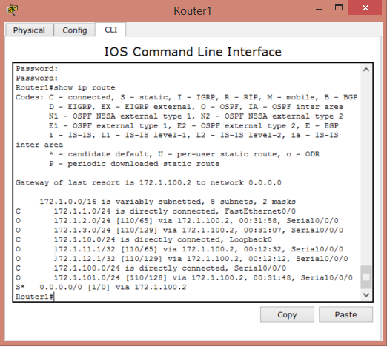

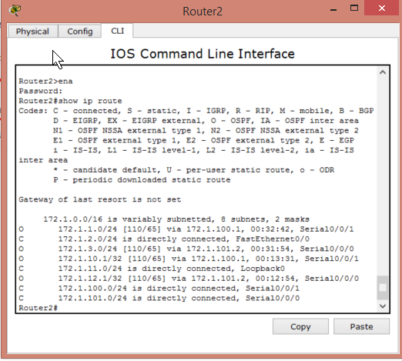

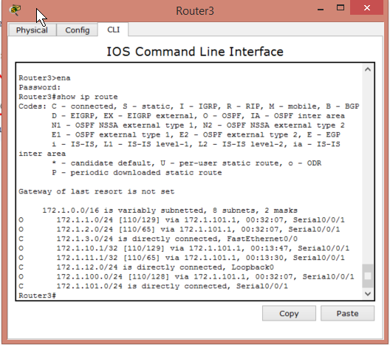

**

**

**

*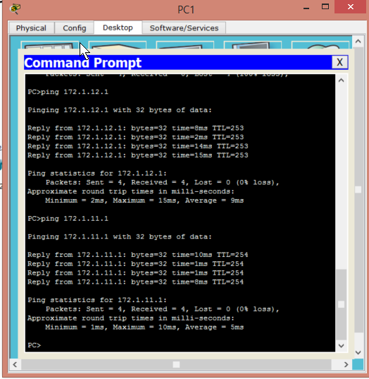pings to loopback interfaces*

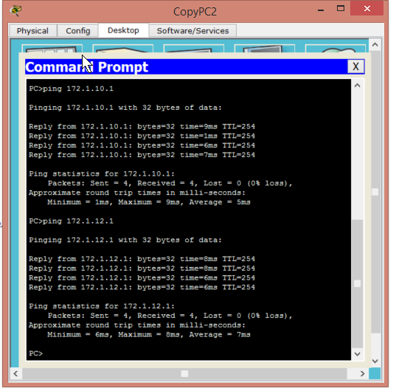

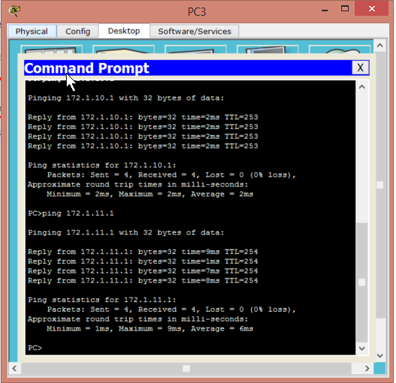

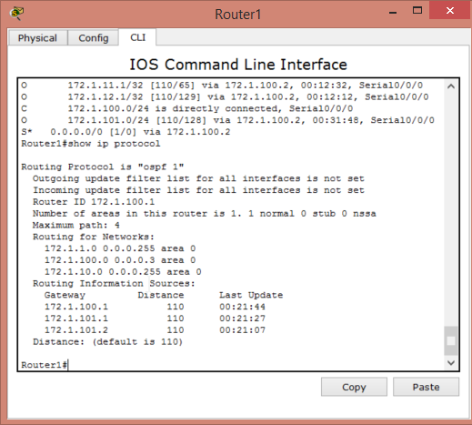

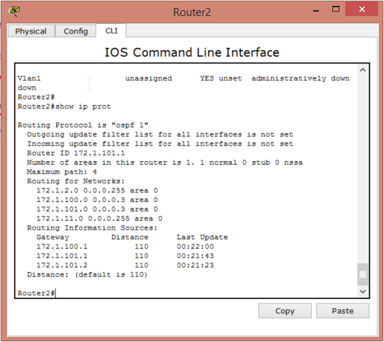

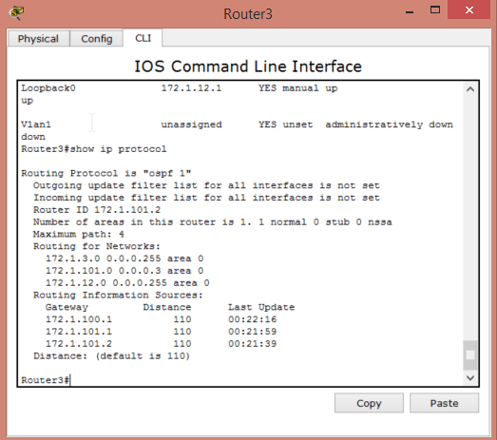

*Show ip int brief*

*Show ip protocol*

*Show ip route(10 points)*

1. Standard ACLs and Standard Named ACLs (NOTE: how, where and why you applying these…)

A: Standard access lists are used to filter network traffic by allowing a user to permit or deny packets from certain subnets. In this example I created two access lists, one named and one numbered in order to control the network traffic going to Server1. The numbered access list denies any traffic from the 172.1.2.0 subnet and the named access list denies any traffic from the 172.1.3.0 network. Apply standard access lists as close as the destination you wish to limit network traffic to.

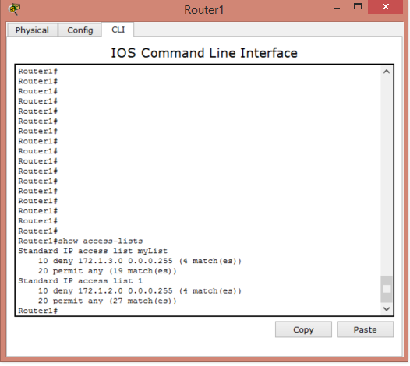

Numbered access list ping test

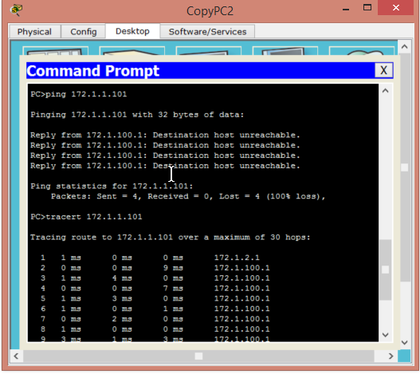

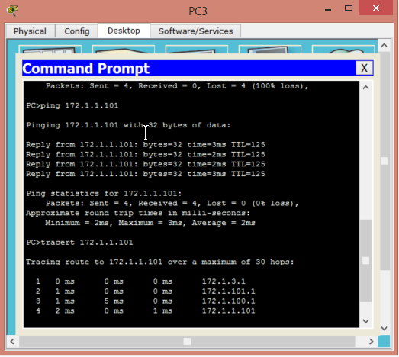

Named Access list ping test

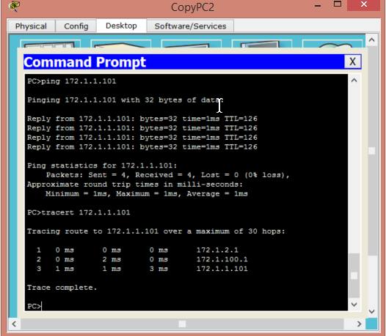

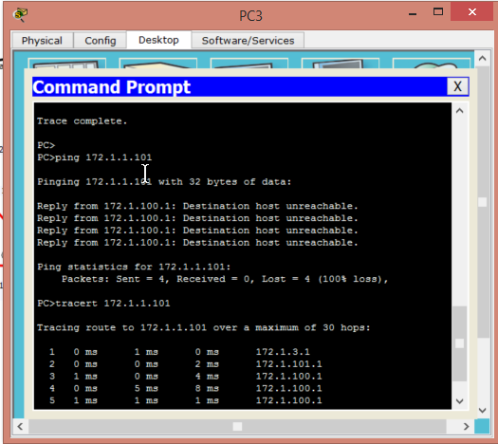

|  |  |
| --- | --- |
| RouterX(config-if)#access-list# deny A.B.C.D Z.Y.X.W | Creates a numbered access list followed by the network you wish to deny and it’s wildcard mask. |
| RouterX(config-if)#access-list# permit any | Allows all other networks to reach the desired destination. |
| RouterX(config-if)#int s0/0/0 ip access-group # in/out | Assigns a numbered access-list to a desired interface. In will apply the access list to any packets being forwarded into the interface, out will apply the access list to any routers going out of the interface. |
|  |  |

*\*Designating which networks you wish to deny and permit is the same between named and numbered access lists.*

|  |  |
| --- | --- |
| RouterX(config-if)#access-list name deny A.B.C.D Z.Y.X.W | Creates a named standard access-list followed by the network you wish to deny and it’s wildcard mask. |
| RouterX(config-if)#int s0/0/0 ip access-group name in/out | Assigns a named access-list to a desired interface. In will apply the access list to any packets being forwarded into the interface, out will apply the access list to any routers going out of the interface. |

Show access-lists

Show run

Show ip int brief *(10 points)*

1. Extended ACLs and Extended Named ACLs (NOTE: how, where and why you applying these…)

Extended access lists deny or permit packets based on source and destination addresses, port numbers, and specific protocols. In this example I created to Extended ACLs on router 2, one denying TCP requests on port 80 and one denying all ICMP packets from the 172.1.2.0 network. Since it is an Extended ACL they are placed as close to the source as possible which is the f0/0 interface on router 2.

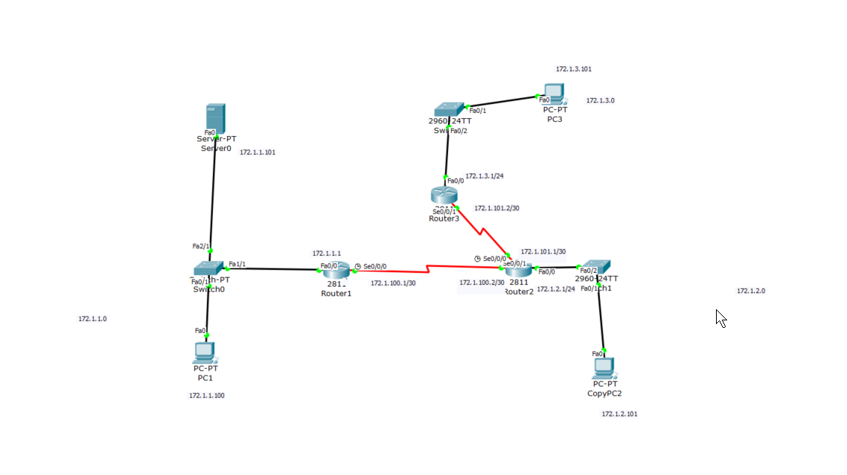

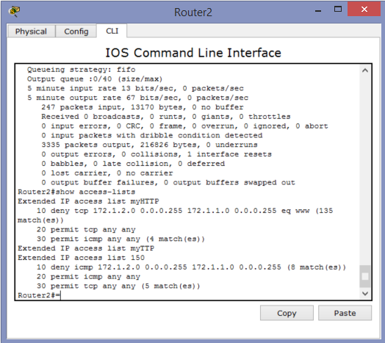

Extended ACL list 150

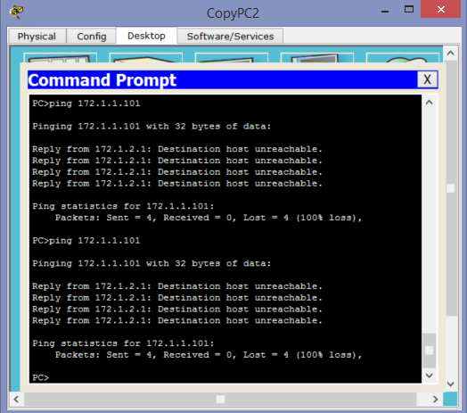

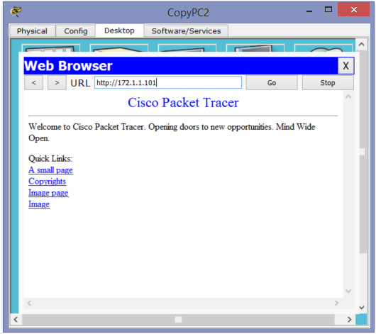

Extended ACL myHTTP

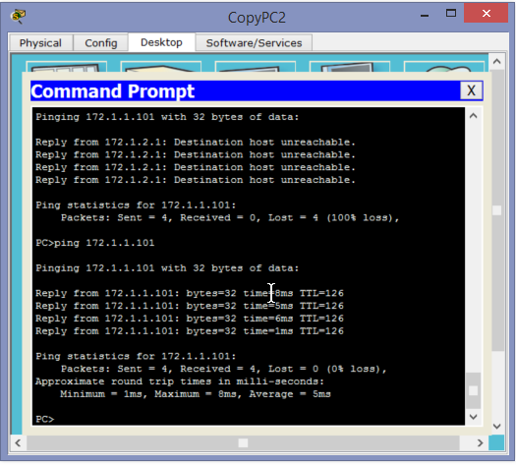

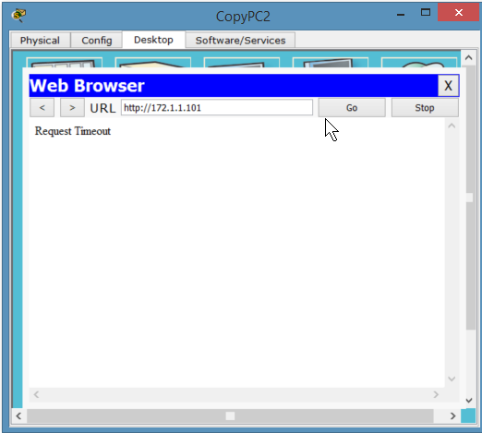

*Named*

|  |  |
| --- | --- |
| Router2(config)#ip access-list extended <name> deny <protocol> <source IP> <wildcard mask> <destination ip> <wildcard mask> eq <protocol> | Creates a named extended access list that denies a specific protocol from a source ip to a destination ip, specifying the specific port to block. |
| Router2(config)#int fx/x | Brings you into the interface you wish to apply the access list to |
| Router2(config-if)#ip access-group <name> in | Assigns the names access list created to a specific interface and assigns it to look at any packets going into the interface. |

*Numbers*

|  |  |
| --- | --- |
| Router2(config)#ip access-list extended <name> deny <protocol> <source IP> <wildcard mask> <destination ip> <wildcard mask> eq <protocol> | Creates a named extended access list that denies a specific protocol from a source ip to a destination ip, specifying the specific port to block. |
| Router2(config)#int fx/x | Brings you into the interface you wish to apply the access list to |
| Router2(config-if)#ip access-group <name> in | Assigns the names access list created to a specific interface and assigns it to look at any packets going into the interface. |

Show access-lists

Show run

Show ip int brief *(10 points)*

1. NAT/PAT (NOTE: Make sure you show a configuration with only NAT, then PAT...remember there are multiple ways to configure PAT. Also show a configuration with static NAT.)

NAT/PAT permits multiples devices on a single network to be mapped to a single IP address. Meaning that in your home network, all of your devices have their own private IP address for the LAN created by your router, but when your router connects your devices to the public domain of the internet, those private IPs get translated into a single Public IP. Essentially, the goal of NAT/PAT is to conserve IP addresses. In NAT, one private IP is translated to one public IP, while in PAT multiple private IP’s are translated into public IPs.

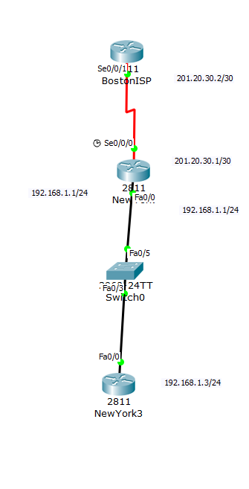

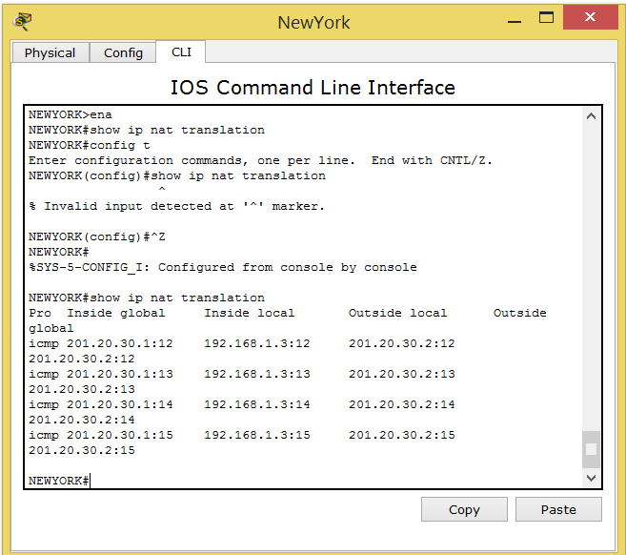

Show ip nat translations

|  |  |
| --- | --- |
| Router(config)# p nat inside source list X interface sX/X/X overload | Configures the NAT protocol to use the public IP that is configured on the serial interface defined. This also ties the access list created to the router. |
| Router(config)#int of wan interface | Brings you into the interface that is the wan connection |
| Router(config-if)#ip nat outside |  |
| Router(config-if)#int of fast ethernet | Brings you into the interface that is the lan connection |
| Rotuer(config-if)#ip nat inside |  |

*(10 points)*

1. DHCP Server and client (NOTE: You should have a DHCP Server for a local and remote network.)

DHCP stands for Dynamic Host Configuration Protocol and is a client/server protocol that automatically provides an IP address to a host along with other basic configuration data like subnet mask and default gateway. In the example below Router2 servers as a DHCP server and has two DHCP pools created, one for each network. What these DHCP pools allow you to do is instead of statically defining the IP address, subnet mask, and default gateway on the PC’s, you can click the DHCP option under IP configuration. This will then look at the appropriate DHCP pool and assign the PC the next available address.

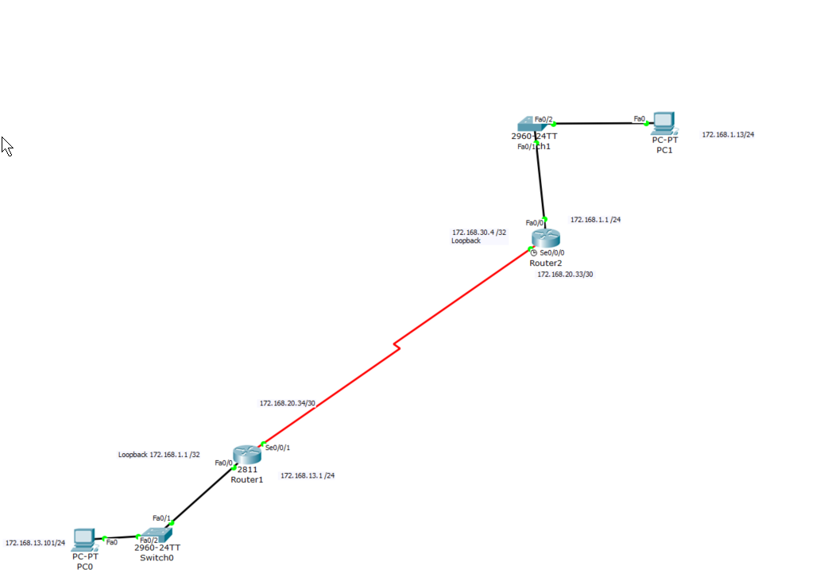

|  |  |
| --- | --- |
| Router(config)#ip dhcp excluded-address <first address in range> <last address in range> | This creates a list of IP’s that will not be assigned to new hosts. In my example, I want my PC to have an IP of A.B.C.13 so I exclude A.B.C.1 – 12 |
| Router(config)#ip dhcp pool <name> | Names the dchp exluded pool created |
| Router(dhcp-config)#network <internal network ip> <internal network subnet mask> | Assigns the desired network to the dhcp pool created |
| Router(dhcp-config)#default router <ip of default router> | Assigns the default router. |
| Router(config-if) ip helpder-address <ip of int closest to dhcp server> | This is used on Router1 in order to change a broadcast signal to an ICMP signal. Assigned an ip of s0/0/0 on Router2 |

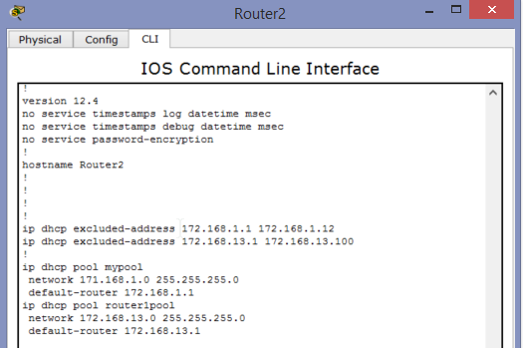

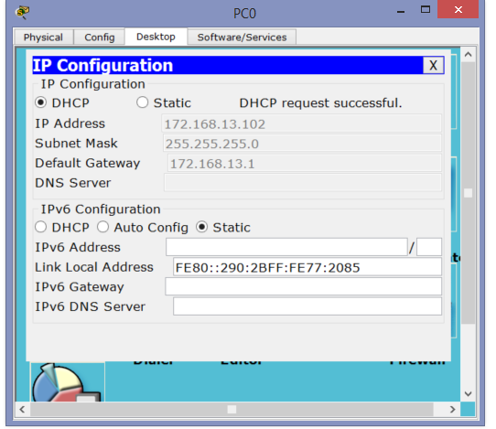*The reason it is a .102 address instead of .101 is because I sent the DHCP request again to make sure it worked, so the server assigned the PC the next sequential address of .102.*(10 points)*

1. PPP, PPP PAP and PPP CHAP (NOTE: you may either provide a topology that utilizes both: PPP PAP and CHAP or create two separate topologies.)

PPP and PPP CHAP are protocols that serve to verify the identity of the peer to peer communication between routers by means of a ‘three was handshake’. The authentication is calculated through a one-way has function in which the authenticator checks the response against its own calculation of the hash value.

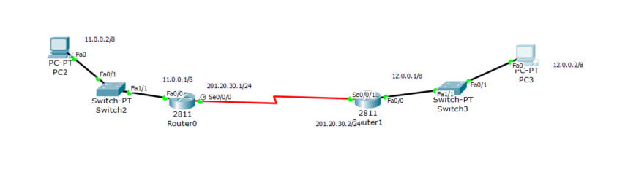

|  |  |
| --- | --- |
| Router(config)#int s0/0/0 | Brings you into the WAN interface of the router |
| Router(config-if)# encapsulation ppp | Changes the layer 2 WAN encapsulation from the default HDLC to PPP |
| Router(config)# username <hostname of other router> password <mypassword> | Creates a username that is the host name of the router you wish to connect to, along with a password which authenticates between both routers at their WAN connections. |
| Router(config-if)# ppp authentication chap | Enables chap authentication instead of ppp. |

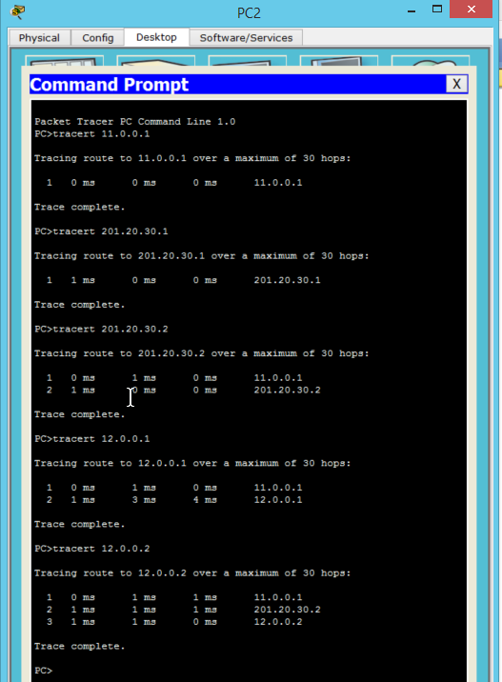

*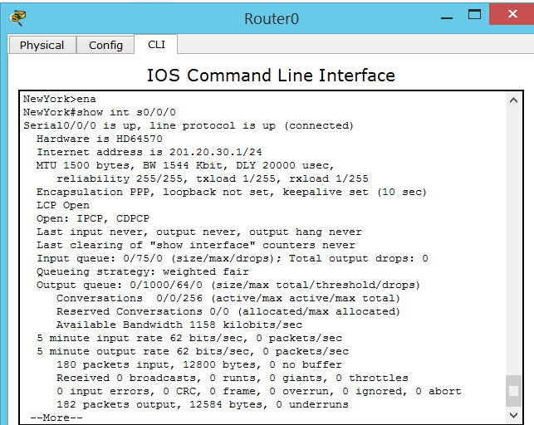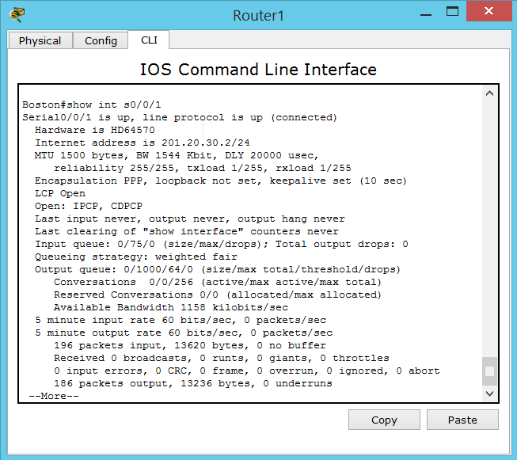show int s0/0/0 show int s0/0/1*

*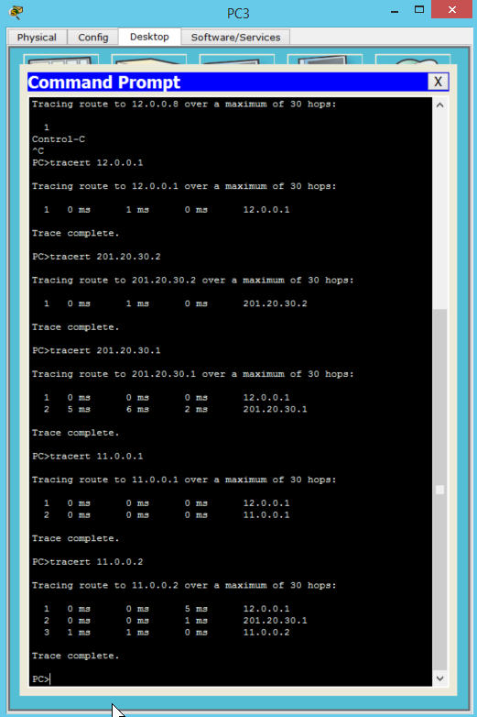(10 points)*

1. Frame Relay (NOTE: You should learn your DLCI numbers automatically from the Frame Relay Switch. Your LMI-Type should be altered from the default LMI-Type. You do NOT need to show a configuration with sub-interfaces for this semester.)

Frame relay is a packet switching service that was designed for cost-efficient data transmissions between LANS and WANS. Routers connect to the “cloud” where frame relay switches are present and handle packet requests.

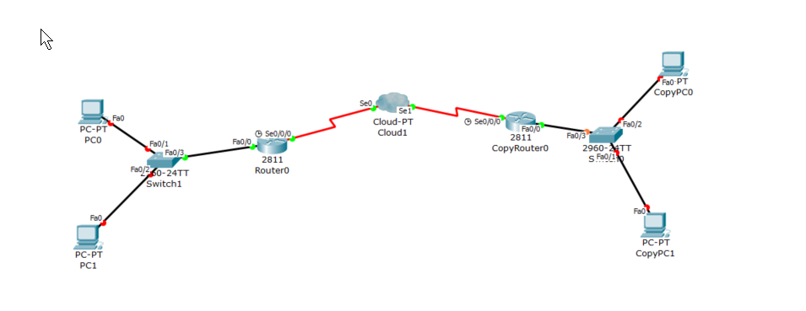

Packet tracer is bugged (surprised) and my connections between my PC’s and switches will not turn green.

|  |  |
| --- | --- |
| Router(config)#encapsulation frame relay | Sets the encapsulation mode of the router to frame-relay |

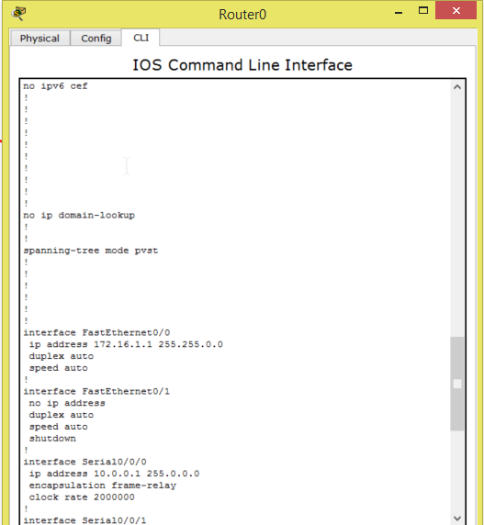

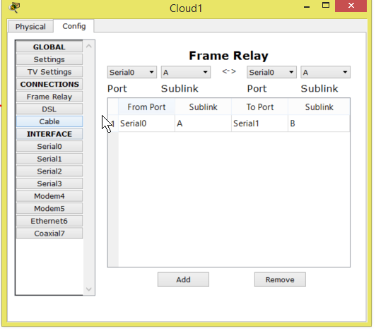

*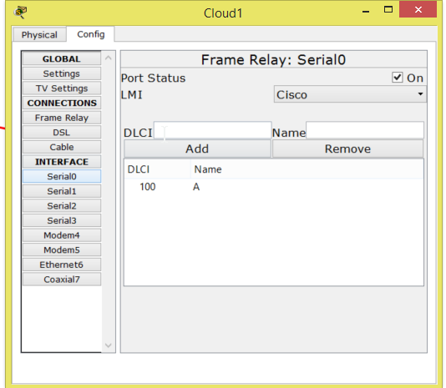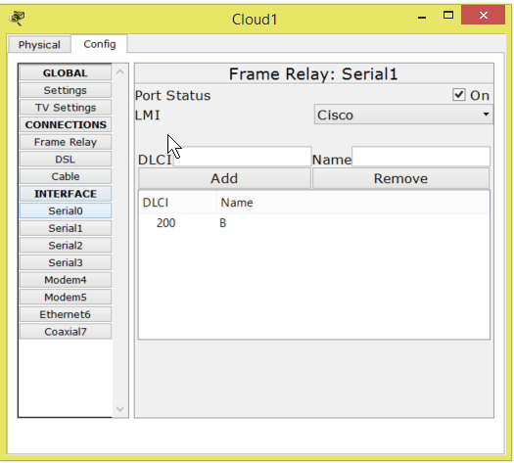(10 points)*

1. IPv6 (Please NOTE: You should still write a paragraph, create a topology, develop a configuration, display the show commands and provide a test case.)

A: IPV6 is the newest version of Internet Protocol and was developed to combat the problem that IPV4 addresses are become exhausted. IPV6 differs from IPV4 by using an 128-bit address which allows 3.4*10^38 possible addresses to be user. However, the difficulty arises because the two protocols are not designed to work in conjunction with each other, which complicates the transition to IPV6, but technology is being developed to allow communication to continue. IPv6 addresses are represented as eight groups of four hex digits.

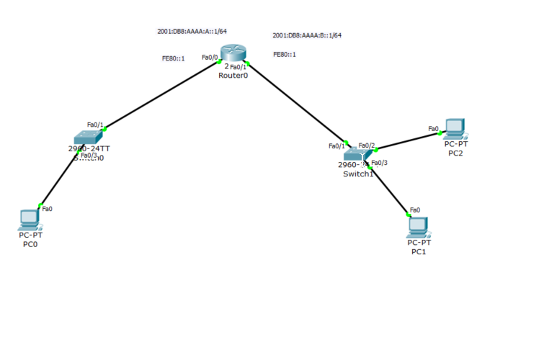

|  |  |
| --- | --- |
| Router(config-if)#ipv6 unicast-routing | Enables the router to handle ipv6 |
| Router(config-if)#ipv6 address FE80::1 link-local | Creates a manual link local address on the router |
| Router(config-if)#ipv6 address <ipv6 address> / 64 | Assigns an ipv6 address to an interface |

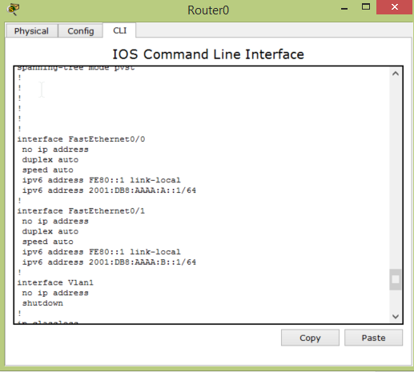

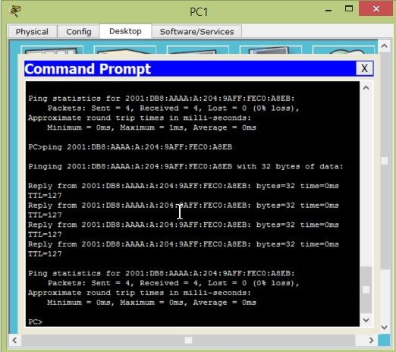

**Part II – (50 Points):**

This part of the project is also extremely detail oriented! Please spend the time necessary to thoroughly complete this assignment since it will be most beneficial to you in the long run!

You should:

* Design your network topology using Cisco Packet Tracer. Your design should consist of Cisco Routers and Cisco Switches.
  + You should have two headquarters routers connected with redundancy to at least two multiple layer switches. The multiple layer switches should connect to at least four layer two switches with redundancy and fault tolerance in mind. At least two servers should exist within your headquarters location. One must be a TFTP server. The other service that exists on the server is up to you.
  + You should have at least five remote sites, each having at least one layer two switch each. At least one of these remote sites should have at least two switches connected together using port aggregation.
  + You should have one internet connection from the headquarters location out to an ISP. On the ISP, there should be at least two servers (ie: at least a DNS server and an HTTP server). The hosts will be great validation points in testing internet connectivity.
  + You should have at least 10 users per remote site and one remote site should have at least 255 users. You should show at least five hosts per location as a proof of concept within your design and within your implementation.
  + You should have at least 1025 users at the headquarters site. Again, you only need to show a subset of those users at key locations within the headquarters site (ie: 10 will be a good number of testing points).
* Design the IPv4 Addressing scheme for your network. Keep in mind you should be using RFC1918 Addressing internally and public ip addressing externally.
* Once your design is complete, configure the network within Cisco Packet Tracer 6.2 or greater as a “proof of concept” for your design.
* You must use at least ten of the technologies or protocols listed in Part I within your design and implementation.

*PLEASE NOTE: There are topics that you must inherently include due to the design specifications. These may or may not be listed within the technologies above (ie: First Hop Redundancy Protocol (ie: HSRP) and Link Aggregation…just to name two).*

This assignment should be **printed and turned in by 12:30pm Tuesday, December 08, 2015.** **In addition to your printed copy, please submit a softcopy in Microsoft Word (.docx or .doc) format via ilearn.** Make sure you cite your resources and do not plagiarize! **All work should be completed individually!!!** **There will not be any extensions given for this assignment**, so make sure you **SUBMIT IT ON TIME otherwise you will receive a grade of ZERO!!!**